**Royal University of Phnom Penh**

**Faculty of Engineering**

**Report Calculator**



**Department : IT Engineering**

**Course : Advanced Programming Language**

**Instructor : Kor Sokchea**

**Year : 2**

**Generation : 7th**

**Semester : 4**

**Date : Saturday, 13 August 2022**

**Name : Pho SoPhors**

**Content**

**ABSTRACT**

1. **INTRODACTION**
2. **BASIC FUNCTION AND DESCRIPTION WITH DEMO**
   1. **Arithmetic and Trigonometry**
   2. **Bitwise Operation**
   3. **Money Exchange** 
      1. **Riel to other currencies**
      2. **Other currencies to riel**
   4. **Storage Converter**
      1. **Byte to (KB, MB, GB, TB, PB)**
      2. **Kilobyte to (B, MG, GB, TB PB)**
      3. **Megabyte to (B, KB, GB TB, PB)**
      4. **Gigabyte to (B, KB, MB, TB, PB)**
      5. **Terabyte to (B, KB, MB, GB, PB)**
      6. **Petabyte to (B, KB, MB, GB, TB)**
   5. **Number System Conversion**
   6. **Binary Arithmetic**
3. **SYSTEM DESIGN**
4. **APPLICATIONS**
5. **TESTING**
6. **CONCLUSION**
7. **REFERENCES**

**ABSTRACT:** Calculators are part and parcel of modern education. Involvement of science and engineering in different fields of knowledge is increasing with each bit of time is passed by, and they are playing a role in description and characterization of the delicate phenomena of nature arising day by day. These fields of knowledge and mathematics in particular, are influencing even those distant branches of knowledge, which were so far imagined to be free of mathematics. Even art is not free of mathematics and there exists mathematical art. Computations are getting lengthy and complex specially in design and analysis of engineering systems. Scientific calculators are handy tools. But an efficient computation is a skill that can be developed.

It is a scientific calculator application. It is used to calculate the math functions easily. In this application two types of calculator are there 1. standard calculator 2. Scientific calculator first one is very simple to solve arithmetic operations. And also convert the result into either integer or float pointing number.  
  
And then second one is scientific notation type math functions are there like sin, cos, tan, log etc. it is very useful to solve the odd math calculations in less time and in simple manner and also easily to use.  
  
Especially I used menu bar with two items one is standard and second one is scientific after clicking the standard item it will shows the standard calculator after clicking the scientific item it will shows the scientific calculator with standard also.  
  
By using Tintern in python I developed this application it is also converted into .exe file by using installer then it is now a desktop application. Lastly it shows desktop icon in our system if u install it otherwise not show in your desktop.

1. **INTRODACTION**

The first scientific calculator that included all of the basic features above was the programmable Hewlett-Packard HP-9100A,[1] released in 1968, though the Wang LOCI-2 and the Mathatronics Mathatron had some features later identified with scientific calculator designs. The HP-9100 series was built entirely from discrete transistor logic with no integrated circuits, and was one of the first uses of the CORDIC algorithm for trigonometric computation in a personal computing device, as well as the first calculator based on reverse Polish notation entry. HP became closely identified with RPN calculators from then on, and even today some of their high-end calculators (particularly the long-lived HP-12Cfinancial calculator and the HP-48 series of graphing calculators) still offer RPN as their default input mode due to having garnered a very large following.

1. **BASIC FUNCTION AND DESCRIPTON**
2. **Arithmetic and Tribometry**

|  |  |
| --- | --- |
| **Function** | **Description** |
| Addition  “+” | The addition (sum function) is used by clicking on the “number” button a and then click on “+” and then click “number” button b. The function results in a + b. |
| Subtraction  “-“ | The subtraction (minus function) is used by clicking on the “number” button a and then clicking on "-" button and then click “number” button b. The function results in a – b |
| Multiplication  “*” | The multiplication (times function) is used by clicking on the "x" button a and then click “number” button b. The function results in a * b. |
| Division  **“/”** | The division (divide function) is used by clicking on the “number” button a and then clicking on "/" button and then click “number” button b. The function results in a/b. |
| Modulus  “%” | The modulus (modulus function) is used by clicking on the “number” button a and then clicking on "%" button and then click “number” button b. The function results in a % b. |
| sign  “±” | The sign (sign function) is used by clicking on the “number” button a and then clicking on "± " button and then click “number” button b. The function results in -1 * a. |
| sin | The sin (sin function) is used by checking on the button “number” and then clicking on “sin” button. The function result in sin(a radian). |

|  |  |
| --- | --- |
| cos | The cos (cos function) is used by checking on the button “number” and then clicking on “cos” button. The function result in cos(a radian). |
| tan | The tan (tan function) is used by checking on the button “number” and then clicking on “tan” button. The function result in tan(a radian). |
| sind | The sind (sind function) is used by checking on the button “number” and then clicking on “sind” button. The function result in sind(a degree). |
| cosd | The cosd (cosd function) is used by checking on the button “number” and then clicking on “cosd” button. The function result in cosd(a degree). |
| tand | The tand (tand function) is used by checking on the button “number” and then clicking on “tand” button. The function result in tand(a degree). |
| sinh | The sinh (sinh function) is used by checking on the button “number” and then clicking on “sinh” button. The function result in sind(a degree). |
| cosh | The cosh (cosh function) is used by checking on the button “number” and then clicking on “cosh” button. The function result in cosh(a degree). |
| tanh | The tanh (tanh function) is used by checking on the button “number” and then clicking on “tanh” button. The function result in tanh(a degree). |
| x factored  “x!” | The x! (x! function) is used by checking on the button “number” and then clicking on “x!” button. The function result in a * x!. |
| Square  “x²” | The square (square function) is used by checking on the button “number” and then clicking on “x²” button. The function result in a². |
| Square three “x³” | The square three (square three function) is used by checking on the button “number” and then clicking on “x³”button. The function result in a³. |
| PI “∏” | The pi (pi function) is used by checking on the button “number” and then clicking on “∏” button. The function result in a * ∏. |
| Square root “√” | The square (square function) is used by checking on the button “number” and then clicking on “√” button. The function result in √a. |
| root three  “∛” | The root three (root three function) is used by checking on the button “number” and then clicking on “∛” button. The function result in ∛a. |
| root four  “∜” | The root four (root four function) is used by checking on the button “number” and then clicking on “∜” button. The function result in ∜a. |
| Clear  “c” | The clear (clear function) if user when to clear number in textField, user can clicking on “c” button so textFiledis cleared. |

1. **Bitwise Operation**

|  |  |
| --- | --- |
| **Function** | **Description** |
| And  “&” | The and (and function) is used by clicking on the “number” button a and then click on “&” and then click “number” button b. The function results in a & b. |
| OR  “|” | The or (or function) is used by clicking on the “number” button a and then click on “|” and then click “number” button b. The function results in a | b. |
| XOR  “^” | The xor (xor function) is used by clicking on the “number” button a and then click on “^” and then click “number” button b. The function results in a ^ b. |
| Complement  “~" | The complement (complement function” is used by clicking on the “number” button a and then click on “~” and then click “number” button b. The function results in a ~ b. |

|  |  |
| --- | --- |
| Shift Left  “<<” | The shift left (shift left function” is used by clicking on the “number” button a and then click on “<<” and then click “number” button b. The function results in a << b. |
| Shift Right  “>>” | The shift right (shift right function” is used by clicking on the “number” button a and then click on “>>” and then click “number” button b. The function results in a >> b. |

1. **Money Exchange**
2. **Riel to other currencies**

The Riel to other currencies (riel function) is used by clicking “number” button a and then click on the “=” button.

Example

If user input 10000, so the function results convert :

10000riel = 2.4691358 dollar

10000riel = 2.173913 euro

10000riel = 2.2222223 franc

10000riel = 1.6666666 pound

10000riel = 100.0 bath

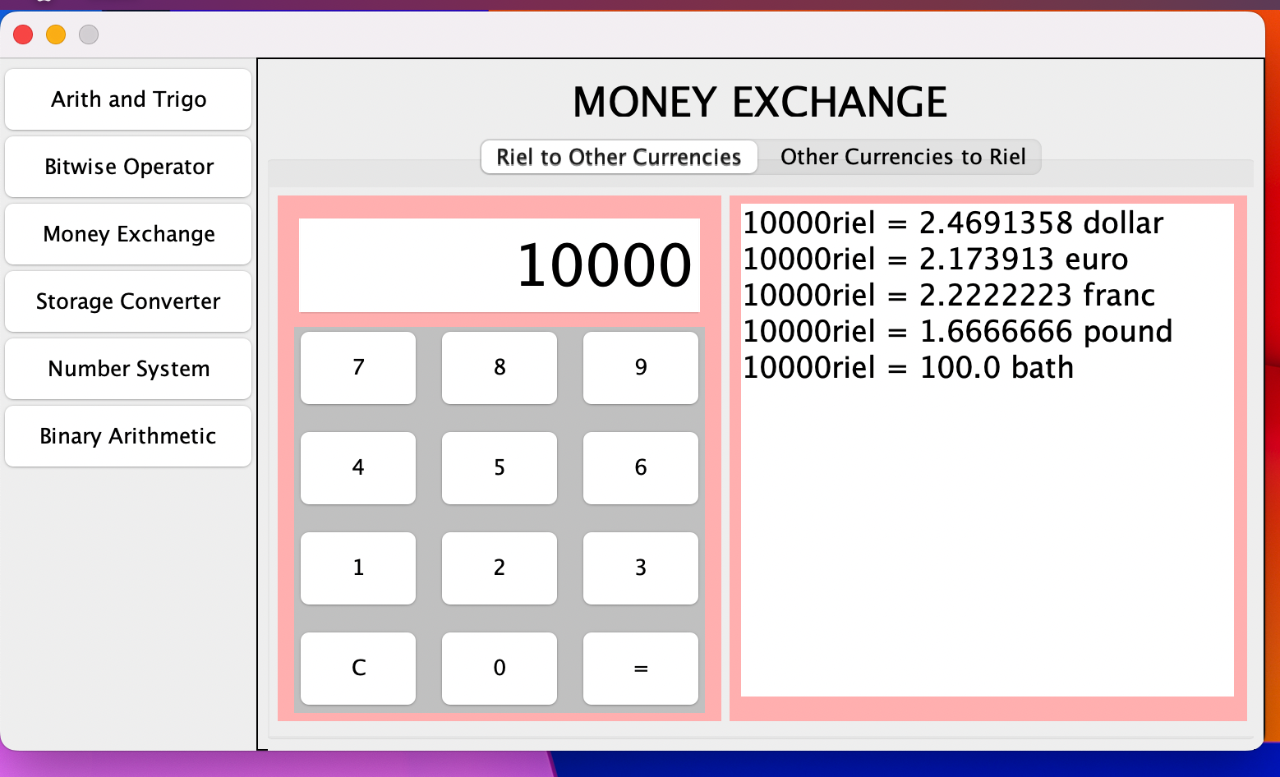

1. **Other currencies to riel**

The Riel to other currencies (currencies function) is used by clicking “number” button a and then click on the “=” button.

Example

If user input 10, so the function results convert :

10.0 dollar = 40500 riel

10.0 euro = 46000 riel

10.0 franc = 45000 riel

10.0 pound = 60000 riel

10.0 bath = 1000 riel

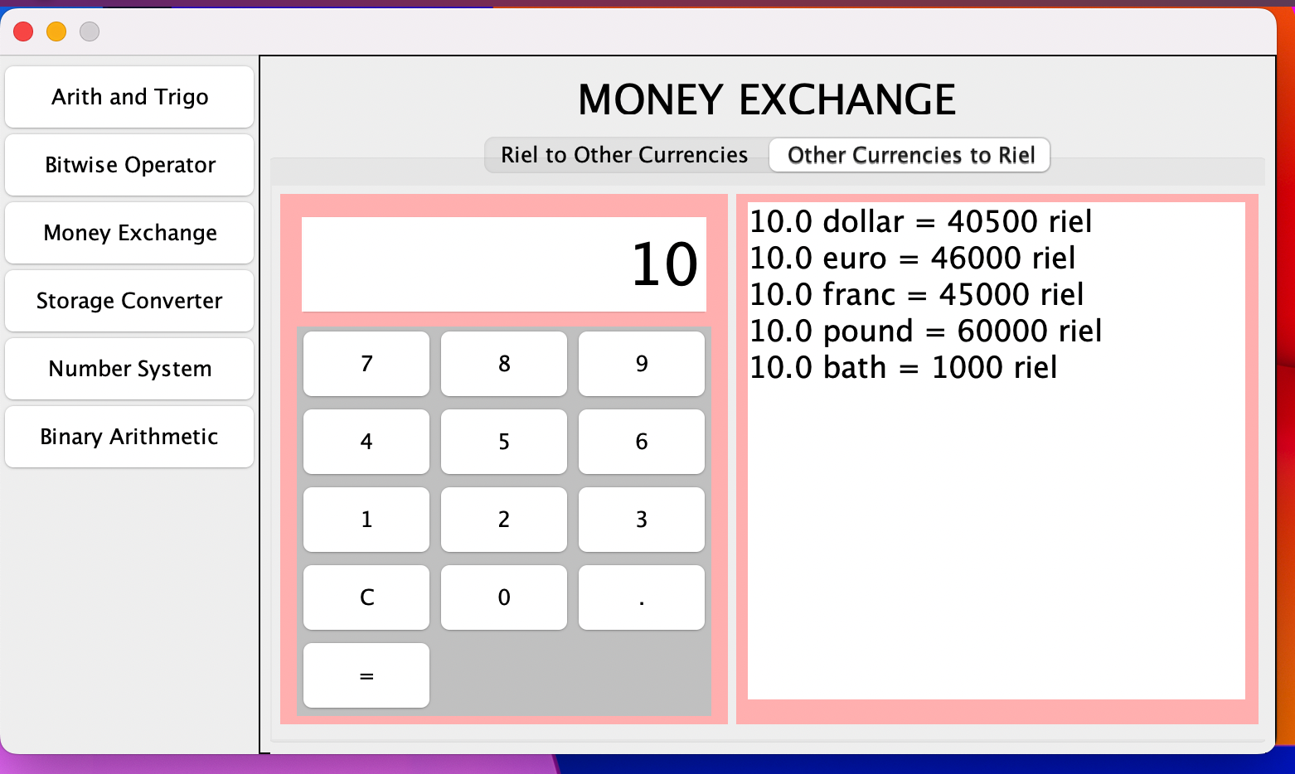

1. **Storage Converter**

**i. Byte to (KB, MB, GB, TB, PB)**

The byte to (KB, MB, GB, TB, PB) (byte function) is used by clicking “number” button a and then click on the “=” button.

Example

If user input 100000, so the function results convert:

100000 B = 97.7 KB

100000 B = 0.0953 MB

100000 B = 9.31E-5 GB

100000 B = 1.0E-7 TB

100000 B = 1.0E-7 PB

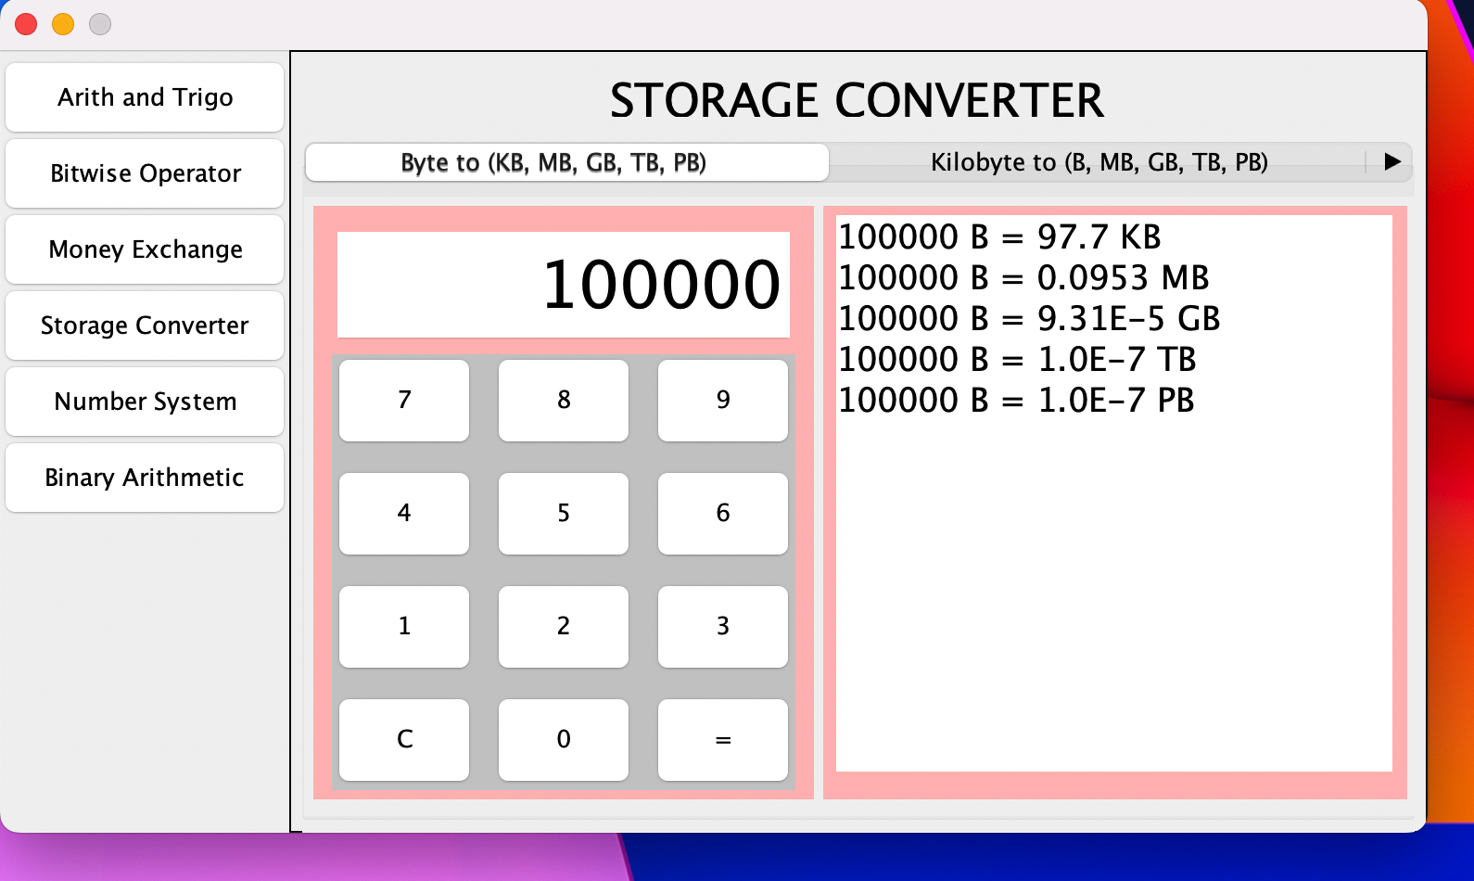

1. **Kilobyte to (B, MG, GB, TB PB)**

The kilobyte to (B, MG, GB, TB PB) (kilobyte function) is used by clicking “number” button a and then click on the “=” button.

Example

If user input 20000, so the function results convert:

20000 KB = 2.048E7 B

20000 KB = 19.4 MB

20000 KB = 0.019074 GB

20000 KB = 1.862E-5 TB

20000 KB = 2.0E-8 PB

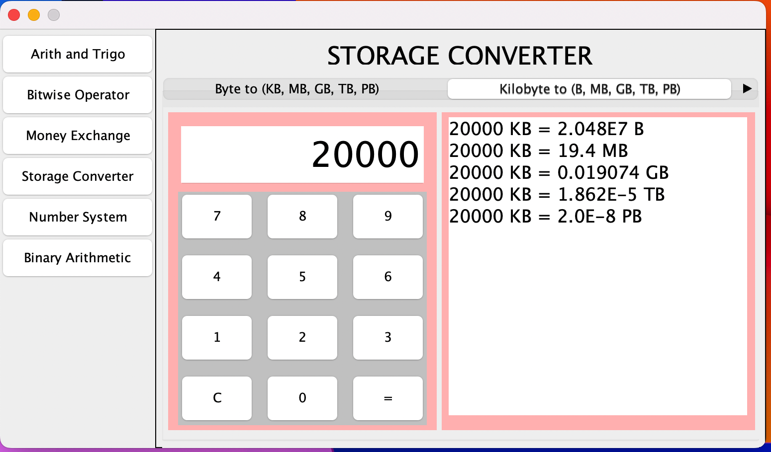

1. **Megabyte to (B, KB, GB TB, PB)**

The Megabyte to (B, KB, GB TB, PB)(kilobyte function) is used by clicking “number” button a and then click on the “=” button.

Example

If user input 5000, so the function results convert:

5000 MB = 5.24288E9 B

5000 MB = 5120000.0 KG

5000 MB = 48.8 GB

5000 MB = 0.0047685 TB

1. = 4.655E-6 PB

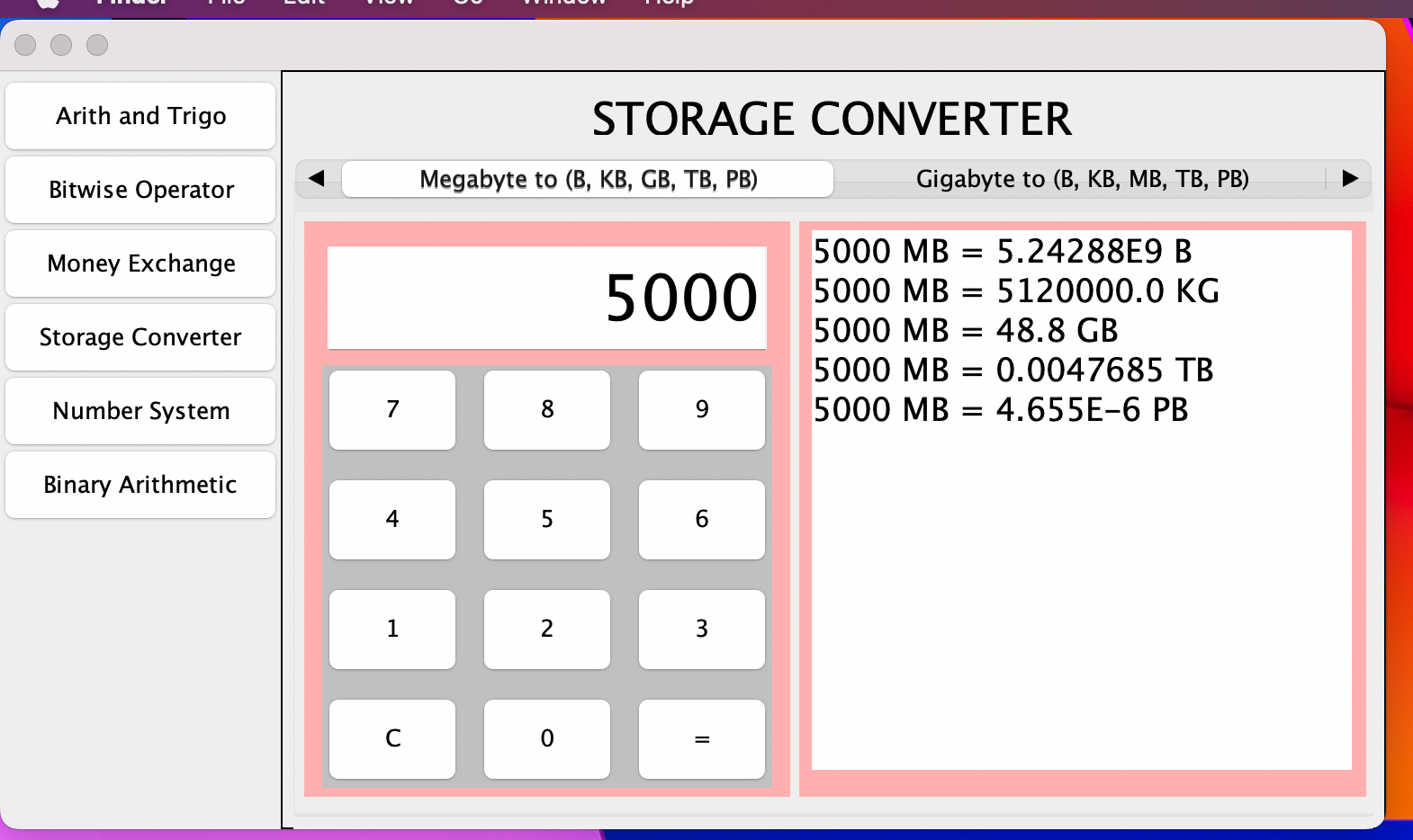 **Iv. Gigabyte to (B, KB, MB, TB, PB)**

The Gigabyte to (B, KB, MB, TB, PB) (gigabyte function) is used by clicking “number” button a and then click on the “=” button.

Example

If user input 50, so the function results convert:

50 GB = 5.3687091E10 B

50 GB = 5.24288E7 KG

50 GB = 51200.0 MB

50 GB = 0.0488 TB

1. B = 4.7685E-5 PB

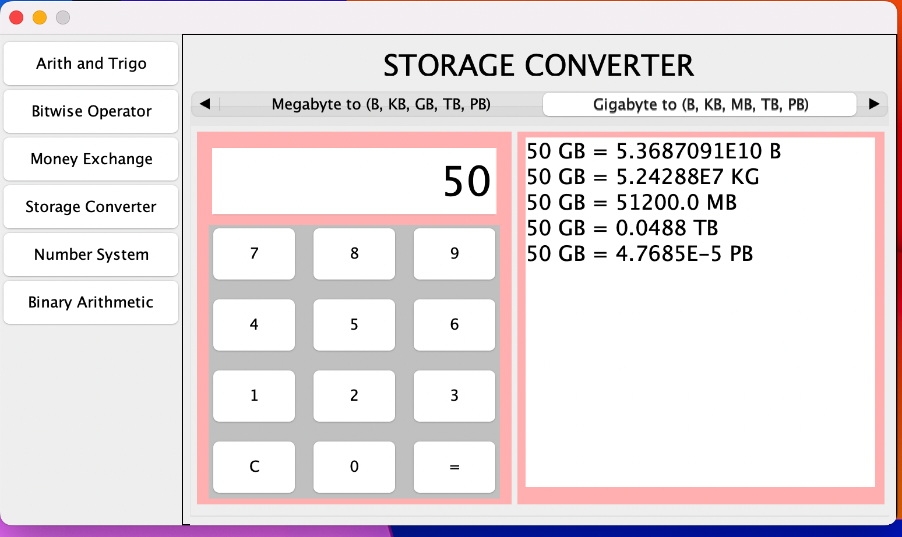

1. **Terabyte to (B, KB, MB, GB, PB)**

The Terabyte to (B, KB, MB, GB, PB)(gigabyte function) is used by clicking “number” button a and then click on the “=” button.

Example

If user input 70, so the function results convert:

70 TB = 7.6965814E13 B

70 TB = 7.5161928E10 KB

70 TB = 7.340032E7 MB

70 TB = 71680.0 GB

1. B = 0.06839 PB

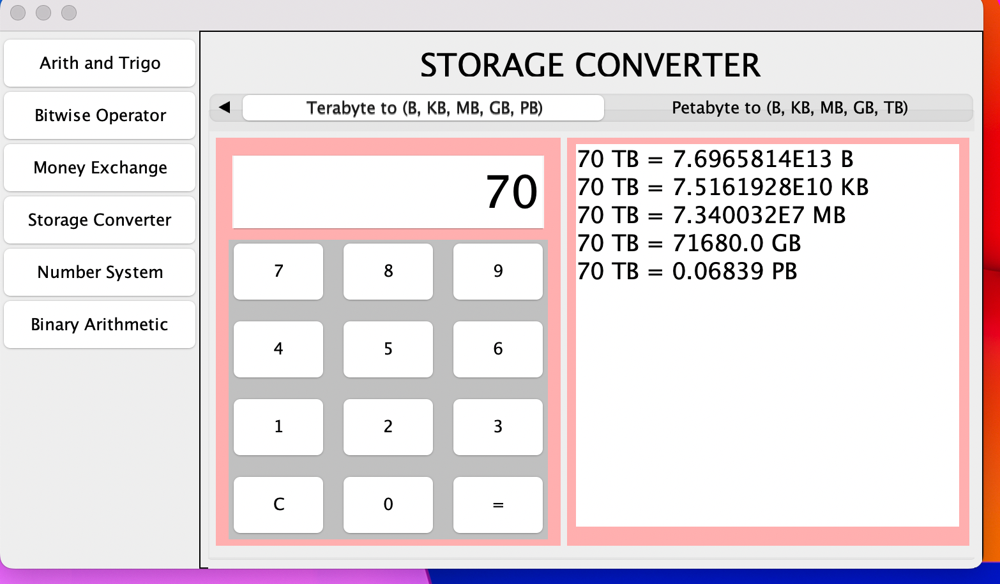

1. **Petabyte to (B, KB, MB, GB, TB)**

The Petabyte to (B, KB, MB, GB, TB) (gigabyte function) is used by clicking “number” button a and then click on the “=” button.

Example

If user input 90, so the function results convert:

90 PB = 1.01330992E17 B

90 PB = 9.8956046E13 KB

90 PB = 9.6636764E10 MB

90 PB = 9.437184E7 GB

90 PB = 92160.0 TB

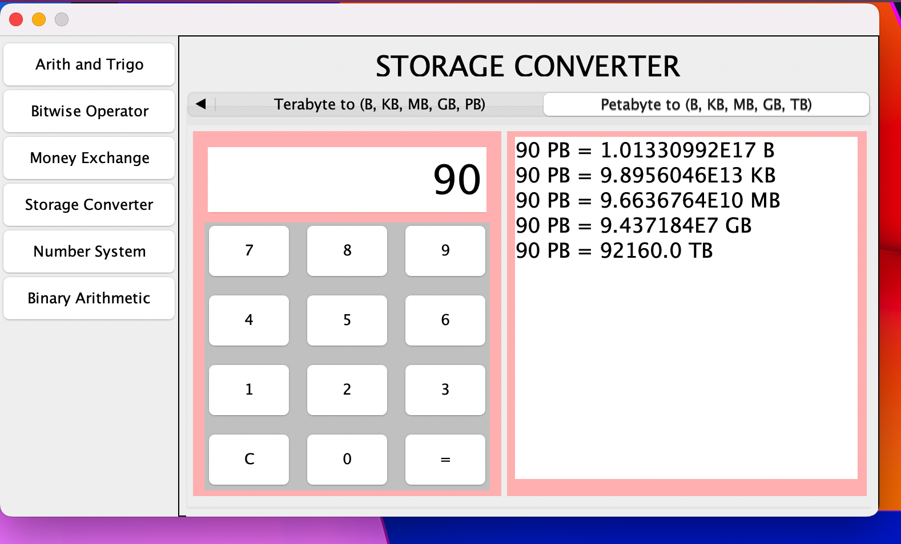

1. **Number System Conversion**

Number system conversion used still the same storage converter

1. **Binary Arithmetic**

Due to some issues, we will upgrade it later.

1. **SYSTEM DESIGN**

Then we began with the design phase of the system. System design is a solution, a “HOW TO” approach to the creation of a new system. It translates system requirements into ways by which they can be made operational. It is a translational from a user-oriented document to a document-oriented programmer. For that, it provides the understanding and procedural details necessary for the implementation. Here we use Flowchart to supplement the working of the new system. The system thus made should be reliable, durable and above all should have least possible maintenance costs. It should overcome all the drawbacks of the Old existing system and most important of all meet the user requirements.

1. **APPLICATION**

In most countries, students use calculators for schoolwork. There was some initial resistance to the idea out of fear that basic arithmetic skills would suffer. There remains disagreement about the importance of the ability to perform calculations "in the head", with some curricula restricting calculator use until a certain level of proficiency has been obtained, while others concentrate more on teaching estimation techniques and problem-solving. Research suggests that inadequate guidance in the use of calculating tools can restrict the kind of mathematical thinking that students engage in. Others have argued that calculator use can even cause core mathematical skills to atrophy, or that such use can prevent understanding of advanced algebraic concepts.

There are other concerns - for example, that a pupil could use the calculator in the wrong fashion but believe the answer because that was the result given. Teachers try to combat this by encouraging the student to make an estimate of the result manually and ensuring it roughly agrees with the calculated result. Also, it is possible for a child to type in −1 × −1 and obtain the correct answer '1' without realizing the principle involved. In this sense, the calculator becomes a crutch rather than a learning tool, and it can slow down students in exam conditions as they check even the most trivial result on a calculator.

1. **TESTING**

Testing is the major control measure used during software development. Its basic function is to detect errors in the software. During requirement analysis and design, the output is a document that is usually textual and no executable. After the coding phase, computer programs are available that can be executed for testing purpose. This implies that testing not only, has to uncover errors introduced during coding, but also errors introduced during previous phase. Thus, the goal of testing is to uncover the requirements, design and coding errors in the programs. The Source code declared above for the program of Scientific Calculator has been tested and it has been found that the above source code is okay and correct. The program involves many types of conversions. These conversions have to done carefully.

1. **CONCLUSION**

The effectiveness of the scientific calculator in solving non-linear equations by the Newton Raphson method has been verified in this study. The usage of the scientific calculator in solving non-linear equations by the Newton-Raphson method improves students’ marks. Students’ marks increased after the respondents were exposed to the method of solving the non-linear equations by the Newton-Raphson method by using scientific calculator. Time reduced tremendously when the participants answered questions utilizing the Casio fx-570ES scientific calculator. This research also shows that the common mistakes made by the participants are reduced after they were taught the technique to solve the problem using the calculator

1. **REFERENCES**

[1] <https://en.wikipedia.org/wiki/Calculator#CITEREFSmith1929>

is an example of such rounding errors -- the algorithm's arcsin(arccos(arctan(tan(cos(sin(9)))))) should come out 9 on standard floating point hardware, but for CORDIC it's a pathological case that produces different rounding errors on each chip that it is implemented on. The algorithm is primarily used to identify the manufacturer of a particular calculator's CPU, since it is usually reproducible between chips of the same model.

[2] <https://www.programiz.com/c-programming/bitwise-operators>

[3] <https://www.calculator.net/>

[4] According to Schmandt-Besserat 1981, these clay containers contained tokens, the total of which were the count of objects being transferred. The containers thus served as a bill of lading or an accounts book. In order to avoid breaking open the containers, marks were placed on the outside of the containers, for the count. Eventually (Schmandt-Besserat estimates it took 4000 years) the marks on the outside of the containers were all that were needed to convey the count, and the clay containers evolved into clay tablets with marks for the count.

[5] <https://www.desmos.com/scientific>

[6] <https://www.online-calculator.com/>

[7] Georges Ifrah notes that humans learned to count on their hands. Ifrah shows, for example, a picture of Boethius (who lived 480–524 or 525) reckoning on his fingers in Ifrah 2000, p. 48.

[8] <https://calculator.com/>

[9] <https://www.calculatorsoup.com/calculators/math/basic.php>

[10]

[11] <https://arxiv.org/abs/0712.1187>